Ray Brown-amory
[Company name] | [Company address]
Fists of the Fallen City
Game title screen Doc

The Title Screen

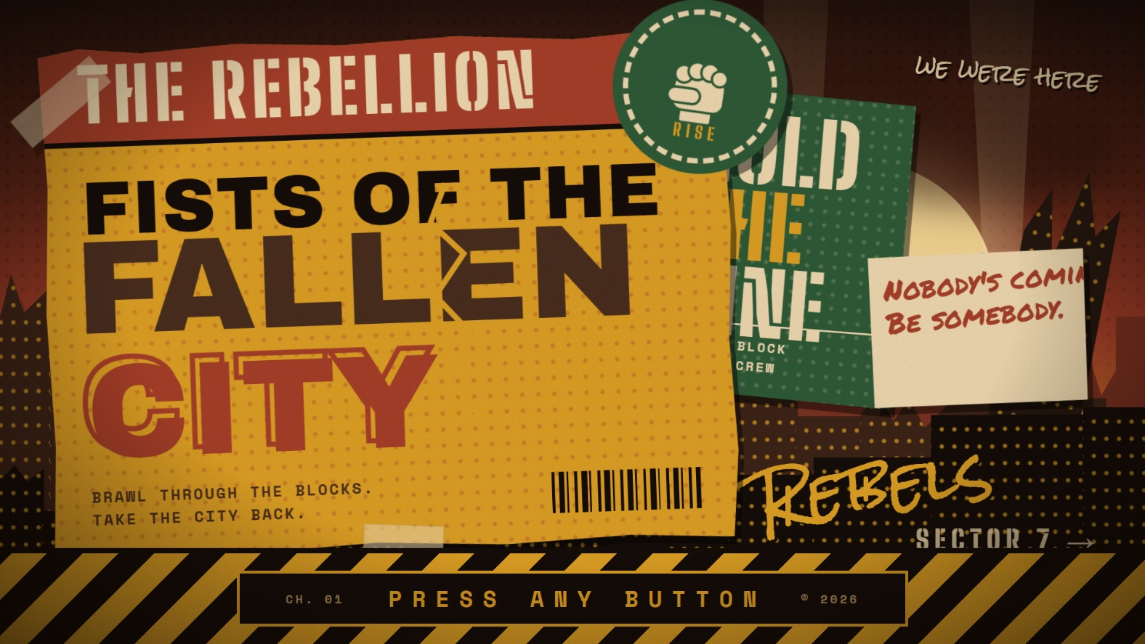

- Title: “THE REBELLION” is a stencil banner across the top of a mustard halftone wheatpaste poster. “FISTS OF THE / FALLEN CITY” is stacked below in huge block type, with a crack splitting it and a raised-fist stamp in the corner. The poster has torn edges and tape.
- City: a fallen skyline in layered silhouettes with lit windows and one tower toppled over. Smoke drifts and searchlights sweep across a dusk sky.
- Urban writing: two smaller pasted sheets read “HOLD THE LINE” and “Nobody’s coming. Be somebody.” There’s a dripping “Rebels” spray tag, a stencilled “Sector 7 →” and a small “we were here” scrawl.
- Prompt: a blinking “PRESS ANY BUTTON” sits in a pill on hazard tape along the bottom. Click, any key or a gamepad button starts a short “Loading the fallen city” bar, then it resets.

